Experiment–2

AIM: First Come First Serve (FCFS)

Theory
First Come First Serve (FCFS) is one of the most basic CPU scheduling algorithms used in operating systems. In this method, the CPU executes processes in the same order in which they enter the ready queue. The process that arrives first is the first one to receive CPU time, following the First-In, First-Out (FIFO) principle.
When a process enters the ready queue, it is placed at the rear (tail) of the queue. The CPU always chooses the process at the front (head) of the queue for execution. Since FCFS is a non-preemptive scheduling algorithm, once a process starts running, it continues executing until it completes without being interrupted. After the process finishes, it is removed from the queue, and the next waiting process is executed.
FCFS is easy to understand and implement because it does not require complex scheduling decisions. However, it is not always efficient. If a process with a long burst time arrives before several shorter processes, the shorter ones must wait until the long process completes. This problem is called the Convoy Effect, which increases waiting time and decreases overall CPU efficiency.
Characteristics of FCFS
- Processes are executed in the exact order in which they arrive.
- It is a non-preemptive scheduling algorithm, meaning a running process cannot be interrupted.
- The algorithm is based on the FIFO (First-In, First-Out) queue structure.
- FCFS is simple to design, implement, and manage.
- Every process eventually gets CPU time, so starvation does not occur.
- The average waiting time may become large when long processes are scheduled before shorter ones.
- FCFS is commonly used in simple batch processing systems, but it is generally unsuitable for interactive and real-time systems because it can result in poor response times.
Program
#include <stdio.h>

struct Process
{
int arrivalTime;
int processId;
int burstTime;
};

void sortProcesses(struct Process p[], int n)
{
int i, j;
struct Process temp;

for (i = 0; i < n - 1; i++)
{
for (j = i + 1; j < n; j++)
{
if (p[i].arrivalTime > p[j].arrivalTime)
{
temp = p[i];
p[i] = p[j];
p[j] = temp;
}
}
}
}

int main()
{
int n, i;

printf("Enter number of processes: ");
scanf("%d", &n);

int arrivalTime[n];
int burstTime[n];
int completionTime[n];
int turnAroundTime[n];
int waitingTime[n];

struct Process processes[n];

/* Input */
for (i = 0; i < n; i++)
{
printf("Enter Arrival Time & Burst Time for Process %d: ",
i + 1);

scanf("%d %d", &arrivalTime[i], &burstTime[i]);

processes[i].arrivalTime = arrivalTime[i];
processes[i].processId = i;
processes[i].burstTime = burstTime[i];
}

/* Sort according to Arrival Time */
sortProcesses(processes, n);

int timer = 0;
float avgTurnAroundTime = 0;
float avgWaitingTime = 0;

/* FCFS Scheduling */
for (i = 0; i < n; i++)
{
if (timer < processes[i].arrivalTime)
{
timer = processes[i].arrivalTime;
}

timer = timer + processes[i].burstTime;

int id = processes[i].processId;

completionTime[id] = timer;

turnAroundTime[id] =
completionTime[id] - arrivalTime[id];

waitingTime[id] =
turnAroundTime[id] - burstTime[id];

avgTurnAroundTime =
avgTurnAroundTime + turnAroundTime[id];

avgWaitingTime =
avgWaitingTime + waitingTime[id];
}

/* Calculate averages */
avgTurnAroundTime = avgTurnAroundTime / n;
avgWaitingTime = avgWaitingTime / n;

/* Display result */
printf("\n");
printf("P\tAT\tBT\tCT\tTAT\tWT\n");

for (i = 0; i < n; i++)
{
printf("P%d\t%d\t%d\t%d\t%d\t%d\n",
i + 1,
arrivalTime[i],
burstTime[i],
completionTime[i],
turnAroundTime[i],
waitingTime[i]);
}

printf("\nAverage Turn Around Time = %.2f\n",
avgTurnAroundTime);

printf("Average Waiting Time = %.2f\n",
avgWaitingTime);

return 0;
}

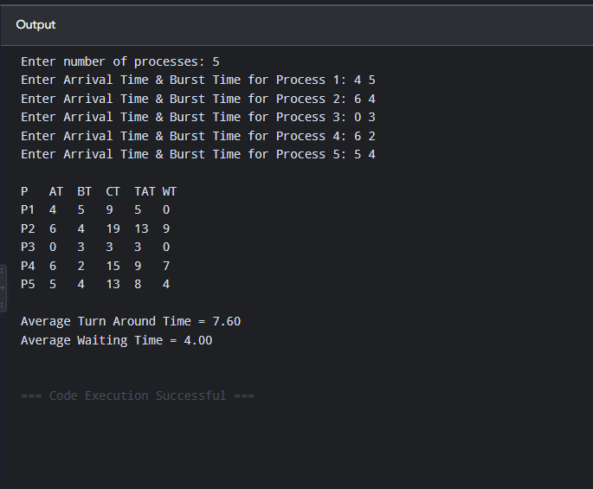
Output

Experiment–3

AIM: Shortest Job First (SJF)
Theory
Shortest Job First (SJF) is a CPU scheduling algorithm in which the process having the shortest Burst Time (BT) is selected for execution first. It is a non-preemptive scheduling algorithm, which means that once a process starts execution, it continues until it is completed.
The scheduler checks all the processes that have arrived and selects the process with the smallest burst time. If two processes have the same burst time, the process with the earlier Arrival Time (AT) is selected first.
The main objective of SJF is to reduce the average Waiting Time (WT) and Turnaround Time (TAT). It is more efficient when the burst time of processes is known or can be estimated accurately.
However, SJF may cause starvation, where a process with a long burst time has to wait for a long time because shorter processes keep arriving.
Characteristics of SJF
- Non-Preemptive: Once a process starts, it runs until completion.
- Shortest Burst Time: The process with the shortest burst time is selected first.
- Arrival Time: Only arrived processes are considered for scheduling.
- Tie Breaking: If burst times are equal, the process with the earlier arrival time is selected.
- Minimum Waiting Time: It helps reduce the average waiting time.
- Minimum Turnaround Time: It helps reduce the average turnaround time.
- Starvation: Longer processes may wait for a long time.
- Burst Time Knowledge: Burst time must be known or estimated in advance.

Formulas
- CT = Completion Time
- TAT = CT − AT
- WT = TAT − BT

Program

#include <stdio.h>
struct Process
{
int pid, at, bt, ct, tat, wt, completed;
};
int main()
{
int n, i, completed = 0, currentTime = 0;
float avgWT = 0, avgTAT = 0;
printf("Enter number of processes: ");
scanf("%d", &n);
struct Process p[n];
// Input
for(i = 0; i < n; i++)
{
p[i].pid = i + 1;

printf("\nProcess P%d\n", i + 1);
printf("Arrival Time: ");
scanf("%d", &p[i].at);
printf("Burst Time: ");
scanf("%d", &p[i].bt);
p[i].completed = 0;
}
while(completed != n)
{
int index = -1;
int minBT = 9999;
// Find process with minimum burst time among arrived processes
for(i = 0; i < n; i++)
{
if(p[i].at <= currentTime && p[i].completed == 0)
{
if(p[i].bt < minBT)
{
minBT = p[i].bt;
index = i;
}
else if(p[i].bt == minBT)
{
if(p[i].at < p[index].at)
index = i;
}
}
}

if(index == -1)
{
currentTime++;
}
else
{
currentTime += p[index].bt;
p[index].ct = currentTime;
p[index].tat = p[index].ct - p[index].at;
p[index].wt = p[index].tat - p[index].bt;
avgWT += p[index].wt;
avgTAT += p[index].tat;
p[index].completed = 1;
completed++;
}
}

printf("\n-----------------------------------------------------------------\n");
printf("PID\tAT\tBT\tCT\tTAT\tWT\n");
printf("-----------------------------------------------------------------\n");

for(i = 0; i < n; i++)
{
printf("P%d\t%d\t%d\t%d\t%d\t%d\n",
p[i].pid,
p[i].at,
p[i].bt,
p[i].ct,
p[i].tat,
p[i].wt);
}

printf("-----------------------------------------------------------------\n");
printf("Average Turnaround Time = %.2f\n", avgTAT / n);
printf("Average Waiting Time = %.2f\n", avgWT / n);

return 0;
}

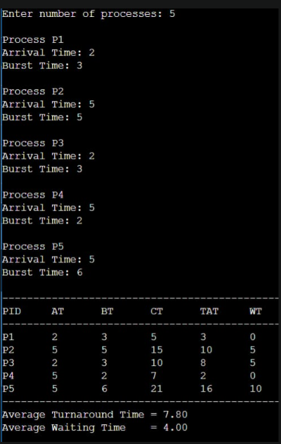
Output

Experiment–4

AIM: Shortest Remaining Job First (SRTF)
Theory
Shortest Remaining Job First (SRTF) is a preemptive CPU scheduling algorithm and is the preemptive version of Shortest Job First (SJF). In this algorithm, the process having the smallest remaining CPU burst time is selected for execution.
Unlike non-preemptive SJF, a running process can be interrupted if a new process arrives with a shorter remaining burst time. The CPU is then assigned to the newly arrived process. The interrupted process is placed back in the ready queue and resumes when it becomes the shortest remaining job.
For example, if a process is running with 5 ms remaining time and a new process arrives with a burst time of 2 ms, the current process is interrupted and the new process is executed first.
SRTF aims to minimize average waiting time and turnaround time. However, frequent process switching can increase context-switching overhead. It may also cause starvation, where a process with a long burst time waits for a long period because shorter processes continue to arrive.

Important Formulas
- Completion Time (CT): Time at which the process finishes execution.
- Turnaround Time (TAT) = CT − AT
- Waiting Time (WT) = TAT − BT

Characteristics of SRTF
- Preemptive: A running process can be interrupted when a shorter process arrives.
- Shortest Remaining Time: The process with the smallest remaining burst time is selected.
- Dynamic Scheduling: Scheduling decisions are made whenever a new process arrives or a process completes.
- Better Response Time: Short processes can get CPU time quickly, providing better response for such processes.
- Low Average Waiting Time: SRTF can provide a low average waiting time when burst times are known accurately.
- Context Switching: Frequent preemption can result in more context switching and additional overhead.
- Starvation: Long processes may wait for a long time if shorter processes continuously arrive.
- Burst Time Required: The remaining burst time of processes must be known or estimated to make scheduling decisions.

Program

#include <stdio.h>
int main()
{
int n, i, time = 0, completed = 0;
int at[10], bt[10], rt[10], ct[10], tat[10], wt[10];
int shortest, min;

printf("Enter number of processes: ");
scanf("%d", &n);

for(i = 0; i < n; i++)
{
printf("\nEnter Arrival Time of P%d: ", i + 1);
scanf("%d", &at[i]);

printf("Enter Burst Time of P%d: ", i + 1);
scanf("%d", &bt[i]);

rt[i] = bt[i];
}

while(completed != n)
{
shortest = -1;
min = 9999;

// Find process with shortest remaining time
for(i = 0; i < n; i++)
{
if(at[i] <= time && rt[i] > 0 && rt[i] < min)
{
min = rt[i];
shortest = i;
}
}

// If no process has arrived
if(shortest == -1)
{
time++;
continue;
}

// Execute process for 1 unit
rt[shortest]--;
time++;

// Process completed
if(rt[shortest] == 0)
{
completed++;

ct[shortest] = time;
tat[shortest] = ct[shortest] - at[shortest];
wt[shortest] = tat[shortest] - bt[shortest];
}
}

printf("\nProcess\tAT\tBT\tCT\tTAT\tWT\n");

for(i = 0; i < n; i++)
{
printf("P%d\t%d\t%d\t%d\t%d\t%d\n",
i + 1, at[i], bt[i], ct[i], tat[i], wt[i]);
}

return 0;
}

Output

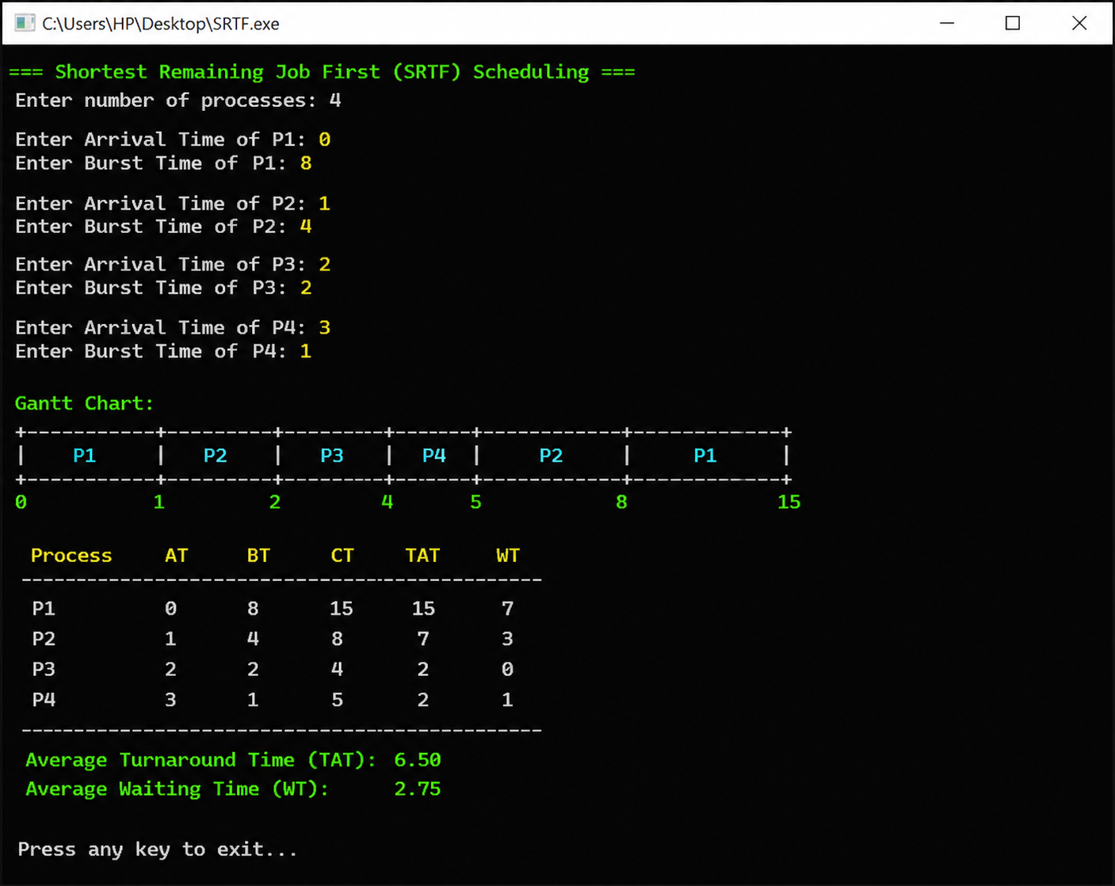

Experiment–5

AIM: Priority Scheduling – Non-Preemptive

Theory
Priority Scheduling is a CPU scheduling algorithm in which each process is assigned a priority. The CPU is allocated to the process having the highest priority.
In Non-Preemptive Priority Scheduling, once a process starts executing, it cannot be interrupted by another process, even if a higher-priority process arrives during its execution. The CPU continues executing the current process until it finishes.
The process with the highest priority among the available processes is selected next. In this implementation, a larger priority number represents a higher priority (e.g., Priority 5 is higher than Priority 3).
If two processes have the same priority, they are generally executed according to FCFS (First Come First Serve) order.

Important Formulas
- Completion Time (CT): Time at which the process finishes.
- Turnaround Time (TAT ): TAT = CT − AT
- Waiting Time (WT): WT = TAT – BT

Characteristics
- Priority-based: Each process is assigned a priority, and the highest-priority process is selected first.
- Non-preemptive: Once a process starts execution, it runs until completion.
- Priority Number: Usually, a smaller priority number indicates a higher priority.
- FCFS for Equal Priority: If two processes have the same priority, the process arriving first is generally selected first.
- Starvation: Low-priority processes may have to wait for a long time if high-priority processes keep arriving.
- Simple to Implement: The algorithm can be implemented by repeatedly selecting the highest-priority process among the available processes.

Program

#include <stdio.h>

struct Process
{
int pid;
int arrivalTime;
int burstTime;
int priority;
int completionTime;
int turnaroundTime;
int waitingTime;
int completed;
};

int main()
{
int n, i;
int time = 0;
int completed = 0;
int index;
int highestPriority;
float totalWT = 0;
float totalTAT = 0;
printf("Enter number of processes: ");
scanf("%d", &n);
struct Process p[n];
for (i = 0; i < n; i++)
{
p[i].pid = i + 1;
printf("\nEnter Arrival Time of P%d: ", i + 1);
scanf("%d", &p[i].arrivalTime);
printf("Enter Burst Time of P%d: ", i + 1);
scanf("%d", &p[i].burstTime);
printf("Enter Priority of P%d: ", i + 1);
scanf("%d", &p[i].priority);
p[i].completed = 0;
}
while (completed < n)
{
index = -1;
highestPriority = -1;
for (i = 0; i < n; i++)
{
if (p[i].arrivalTime <= time && p[i].completed == 0)
{
if (p[i].priority > highestPriority)
{
highestPriority = p[i].priority;
index = i;
}
else if (p[i].priority == highestPriority)
{
if (index == -1 ||
p[i].arrivalTime < p[index].arrivalTime)
{
index = i;
}
}
}
}

if (index == -1)
{
time++;
}
else
{
time = time + p[index].burstTime;

p[index].completionTime = time;
p[index].turnaroundTime =
p[index].completionTime - p[index].arrivalTime;
p[index].waitingTime =
p[index].turnaroundTime - p[index].burstTime;
p[index].completed = 1;
completed++;
}
}
printf("\n-------------------------------------------------------------\n");
printf("Process\tAT\tBT\tPriority\tCT\tTAT\tWT\n");
printf("-------------------------------------------------------------\n");
for (i = 0; i < n; i++)
{
printf("P%d\t%d\t%d\t%d\t\t%d\t%d\t%d\n",
p[i].pid,
p[i].arrivalTime,
p[i].burstTime,
p[i].priority,
p[i].completionTime,
p[i].turnaroundTime,
p[i].waitingTime);
totalWT += p[i].waitingTime;
totalTAT += p[i].turnaroundTime;
}
printf("-------------------------------------------------------------\n");
printf("\nAverage Waiting Time = %.2f", totalWT / n);
printf("\nAverage Turnaround Time = %.2f\n", totalTAT / n);
return 0;
}

Output

